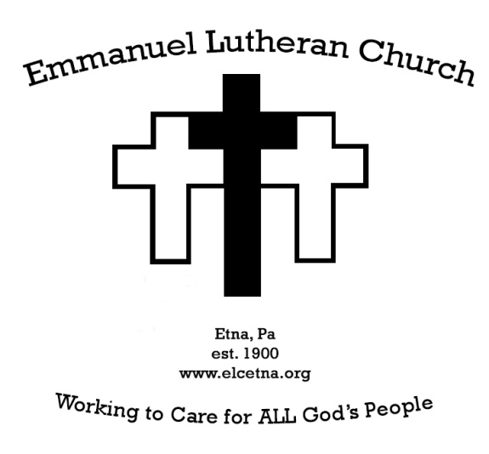

Worship Bulletin & Weekly Announcements
Second Sunday of Easter
April 7, 2024

WELCOME VISITORS!
Welcome to Emmanuel Lutheran Church! We are glad that you are worshiping with us. If you have no church home in this community, why not make Emmanuel your own? Please sign the guest book in the narthex. If you are interested in becoming a member of the congregation, please talk with Pastor JJ, who can be reached by phone at 412-600-6232, or via email at pastor@elcetna.org.

66 Grant Ave. Pittsburgh, PA 15223
Church Phone: (412)781-2764
pastor@elcetna.org
secretary@elcetna.org
www.elcetna.org

Dart-Ball
The last Dartball session was April 1 2024. Thanks to all who joined the fun and fellowship. See you next year.

Opportunities to serve
Opportunities to serve as Lectors, Usher/Greeters, Communion Assistants & Live Stream are now being scheduled for the summer months. Anyone interested in serving can contact Edna Zimmermans or Kathy Suhadolnik by April 14 2024.

125th Anniversary
January 21. 2025 will be our 125th birthday as Emmanuel!
Council is seeking to form a team of people who will plan, organize, and guide the events that will celebrate our next and past 125 years of service to the Gospel through worship, proclamation, baptism, service, nurture, and fellowship.
If you are interested and willing to be a part of this committee, please share that interest with any of your council persons.

What Does This Mean?
What does this mean? Will be a faith formation opportunity, for anyone and everyone, to study and discern together the themes of faith of the current liturgical season.
In the season of Easter we will consider together What does it mean to live a resurrection life of faith?
1pm-2:30pm in the Weisel Room
Wednesday April 10th
Wednesday April 24th
Wednesday May 1st

Altar Flowers
April 7 IMO John Koedel by Carol Koedel
April 14 IMO Ralph Ingold by Dean, Char and family
April 21 Altar - IMO Frank and Marion Kurtz by Karen Krenn
Credence - IMO Al and Babe by Loved Ones
April 28 IMO Rick Dreves by Bev Dreves
May 5 IMO Henry and Ruth Dingfelder by Irene Fugh
May 12 IMO and IHO all women who take on the role of mother
May 19 A- IMO Jean Mahler by her family
Credence- IMO Don Coates by Rachel Coates
May 16 IMO Parents by Carol Koedel

June 2 NEEDED

If you would like to sponsor the altar flowers in memory or honor of a loved one, event, or time, please communicate with Edna Zimmerman edna228@verizon.net (412-487-3554)

Opportunities This Week
Sunday, 04/07 9:15am Worship with Holy Communion
Wednesday 04/10 1pm-2:30pm What Does This Mean?
Class in Weisel Room
Friday (4/5) evening, Saturday (4/6), and Sunday (4/7) afternoon, the Scout troop will be using the Weisel room for a leader training.

Outside groups meeting at Emmanuel
Monday 3-7pm Etna Community Counseling
Center (Anchorpoint)
6:30pm Brownies
Tuesday 7:00pm Boy Scouts
Wednesday 6:30pm Girl Scouts
Thursday Noon-3pm Passages to Recovery
Friday

OUR CONCERN LIST
Members, and Family and friends, of congregation in need of prayer: Charlotte Yoest, Jonah Soegel, mom Kayla and dad Chuck, Douglas E. Krachala and family, Bill Coates and Rachel and family, Jeanne Krachala, Sally Love, Dean Ingold, Susan Conrad and family, Joanne Walsh and family, Mara Comport, Rachel Coates, Gary Jurges, Kathleen McShane, Stephanie Hall and Joseph Oricko, Shirley Simon, Ray Suhadolnik.
Those serving in the military: Rob Umbaugh, Larry Baumiller, III, Dalton Bailey, Pat Sharkey, Evan Stitch.
[note: We ask the families and friends who have requested prayers to please give us a call when your loved one may be removed from our list.]

BULLETIN PRAYER REQUESTS
If you have a prayer request to be added to our concern list, for the prayer chain, or would like to receive prayer requests, please contact Edna Zimmerman (412-487-3554); edna228@verizon.net; or Rachel Coates (412-486-0830). You can also add names to the bulletin prayer list by calling or sending an email to Pastor JJ. Thank you for your prayerful concern and care about our neighbors and friends!

Pastoral Care Needs
When you, members of your family, or friends in the congregation, are in need of pastoral care due to illness, hospitalization or life events, please call Pastor J.J. at
412-600-6232.

Serving today April 7, 2024
Pastor Pastor J.J. Lynn
Communion Assistant Cindy Umbaugh
Live Stream Tom Hough
Greeters/Ushers Stan Grubisa
Amy Scariot
Reader Edna Zimmerman
Altar Guild Edna Zimmerman
Counters Tom Hough
Sue Spelic

Serving next week April 14, 2024
Pastor Pastor J.J. Lynn
Communion Assistant Stan Grubisa
Live Stream Vera Harencame
Greeters/Ushers Sue Spelic
Shari Heller
Reader Irene Fugh
Altar Guild Linda Hennee
Counters Dean Ingold
Edna Zimmerman

Emmanuel’s Congregational Councilpersons
Tom Hough, President
Sue Spelic, Vice-President
Edna Zimmerman, Secretary
Roland Kania, Treasurer
Dean Ingold Kathy Suhadolnik
Danielle Barr Stan Grubisa
Jack Dellert John Mertens
Jaime Renda

Northside Ministry Pleasant Valley Men’s Shelter
Gently used men’s clothing is being collected for our ministry with the Pleasant Valley Men’s Shelter. Items can be left in the hallway between the sanctuary and Sunday School rooms.

Drop off non-perishable food items for Bread of Life:
Monday 2-4 pm
Wednesday 6-8 pm
All Saints School Building – Dewey Street
(monetary donations will also be accepted)
Partners: All Saints Catholic Church, Borough of Etna, Bread of Life Food Pantry, Etna Community Organization, Emmanuel Lutheran Church

WELCA (Women of the ELCA ) Items needed for the after school program at St.Peter's Lutheran Church, Evans City are: Snack donations, apple sauce, pretzels, vegie straws, any snack size bag of treats; paper products - paper towels, napkins, paper plates, etc; craft supplies - glue, scotch tape, beads, construction paper, permanent markers, and items for prizes ( small dollar store items would be great). Please place items in red barrel at side entrance.

Meetings are monthly from September through June each year. They are held the second Thursday of each month at 12:30pm in the Cliff Weisel Room. Won't you join us. Any questions, you can ask one of the board members: Edna Zimmerman, Carol Koedel or Linda Henne.

