Emmanuel Lutheran Church of Etna
Seventeenth Sunday after Pentecost

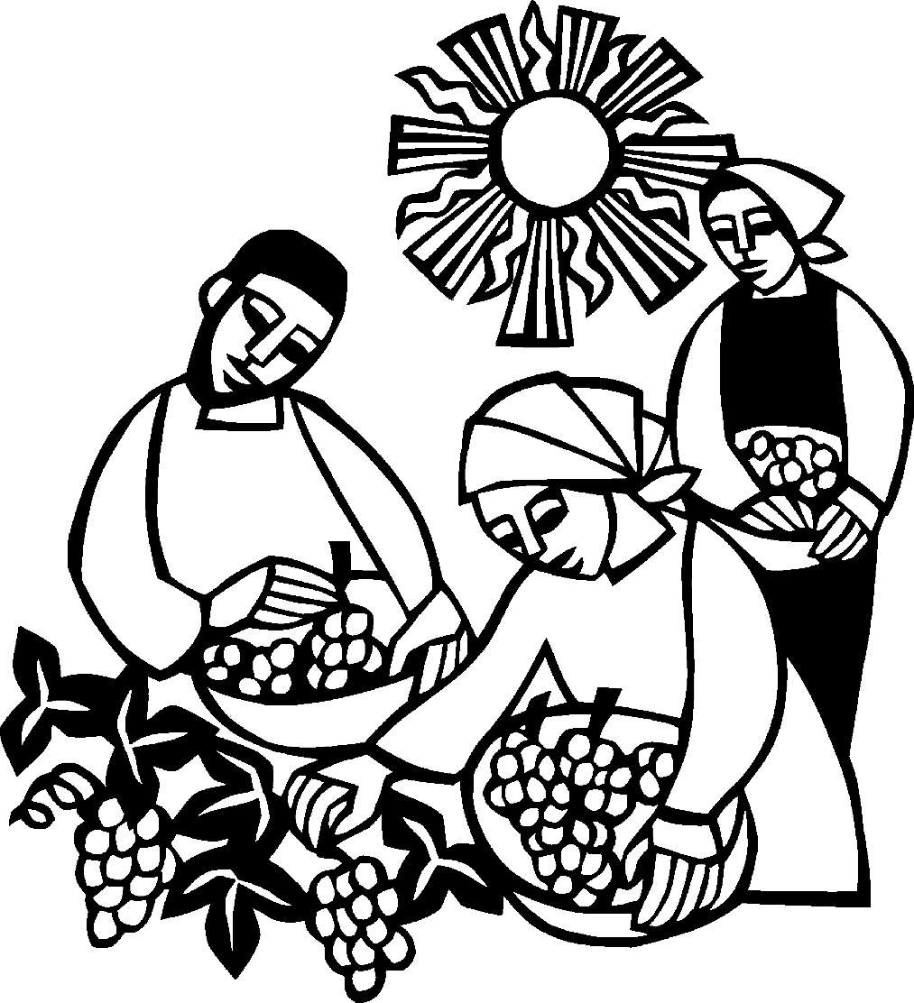

Sunday, September 24, 2023
Rev. Brian Bennett
Preaching and Presiding
Judith Erlen, Organist

Introduction To The Day
Matthew narrates one of Jesus’ controversial parables in which Jesus says that the reign of God is like that of a landowner who pays his workers the same wage no matter what time of day they began to work. When God changes God’s mind about punishing Nineveh for their evil ways, Jonah is angry. Yet God is gracious and merciful, abounding in steadfast love. In baptism we receive the grace of God that is freely given to all. As Martin Luther wrote, in the presence of God’s mercy we are all beggars.
First Reading: Jonah 3:10--4:11
After Jonah’s short sermon in 3:4, the Ninevites all repented and God decided to spare the city. Jonah objected to this and became even more angry when God ordered a worm to destroy a plant that was providing shade. The book ends with a question that challenges any who are not ready to forgive: You, Jonah, are all worked up about a bush, but shouldn’t I be concerned about a hundred and twenty thousand Ninevites?
Second Reading: Philippians 1:21-30
Paul writes to the Philippians from prison. Though he is uncertain about the outcome of his imprisonment, he is committed to the ministry of the gospel and calls on the Philippians to live lives that reflect and enhance the gospel mission.
Gospel: Matthew 20:1-16
Jesus tells a parable about God’s generosity, challenging the common assumption that God rewards people according to what they have earned or deserve.

Gathering
The Holy Spirit calls us together as the people of God.
Welcome and Announcements
Brief announcements may be made, especially those related to the assembly’s participation in God’s mission in the world. Affirmation of Christian Vocation may be used here.
Prelude
Songs of Hope—Ahnfelt/Smith
Confession and Forgiveness
The assembly stands. All may make the sign of the cross, the sign that is marked at baptism, as the presiding minister begins.
Blessed be God,
the one who forms us,
☩ Jesus who bears the cross,
the Spirit who makes our joy complete.
Amen.
Let us bow before God in humility, confessing our sin.
Silence is kept for reflection.
Steadfast and faithful God,
you have revealed the ways of justice, yet we fail to follow you. We are overwhelmed by the world’s violence and suffering. We are afraid to risk what we have for the sake of others.
For the harm we have caused, known and unknown, forgive us.
For the unjust demands we place on ourselves, on others and your creation, forgive us.
For the ways we turn away from you and our neighbor, forgive us.
Lead us back to you and set us on the right path;
in the name of Jesus Christ, our Savior.
Amen.
Beloved in Christ,
God’s justice stretches beyond all understanding.
God’s compassion is beyond compare.
In Jesus, God is always making a new way for us.
In ☩ Christ, you are already and always forgiven.
Amen.
The service continues with gathering song.

Gathering Song Lord of Light (ELW 688)
The time of gathering song may be brief or extended, and may include one or more of the following: hymns, psalms; a Kyrie; a canticle of praise.

Greeting
During this time, the presiding minister and the assembly greet each other.
The grace of our Lord Jesus Christ, the love of God,
and the communion of the Holy Spirit be with you all.
And also with you.

Kyrie
A Kyrie may be sung in dialogue between an assisting minister and the assembly.
Hymn of Praise
One of the following or another canticle of praise may be sung by all.

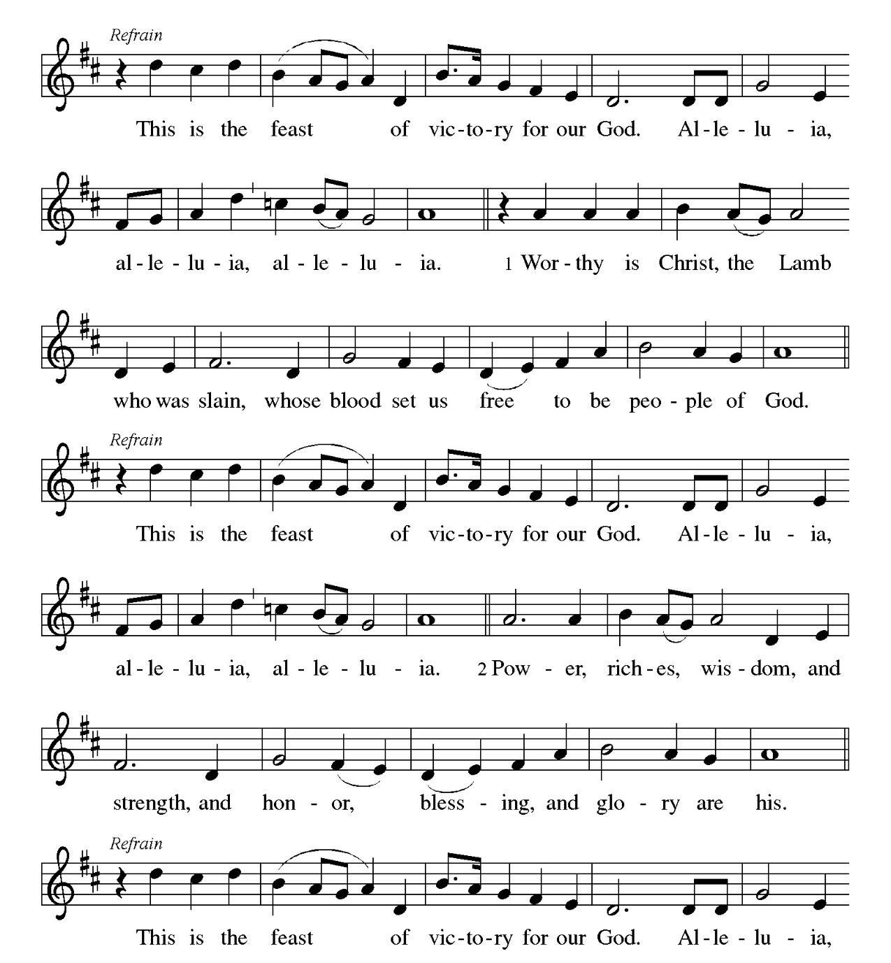

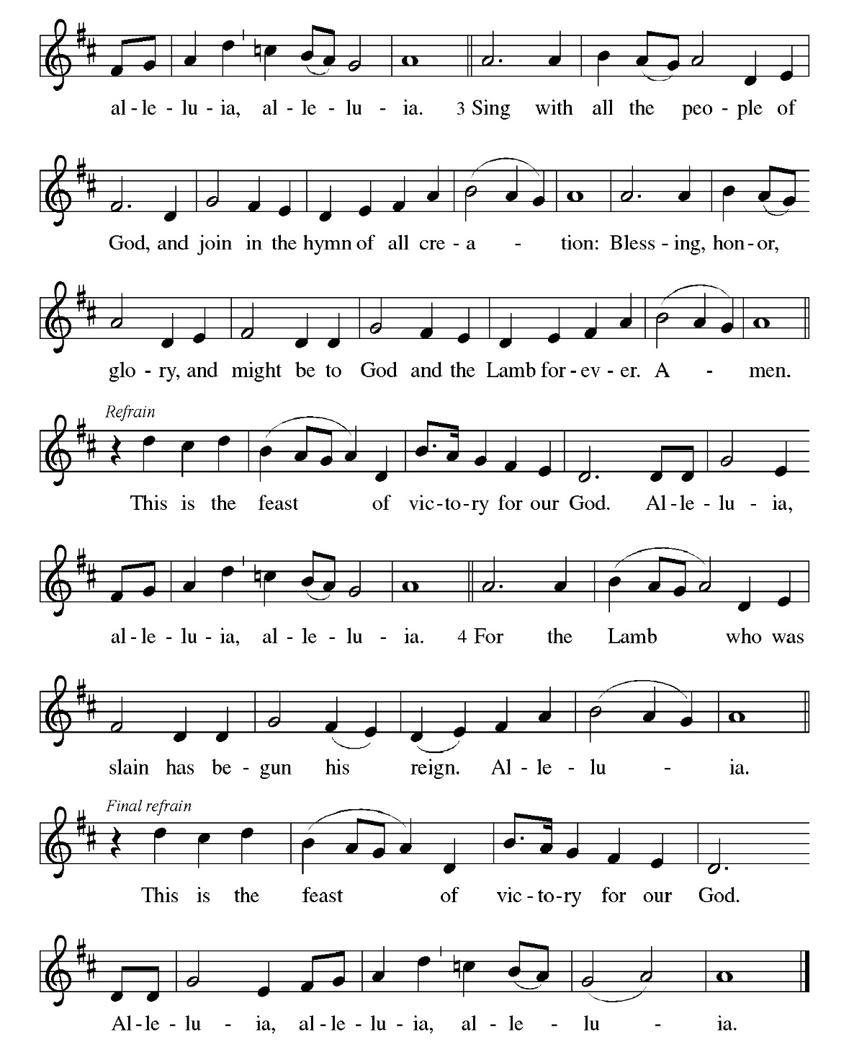

Prayer of the Day
The presiding minister leads the prayer of the day.
Let us pray.
A brief silence is kept before the prayer.
Almighty and eternal God, you show perpetual lovingkindness to us your servants. Because we cannot rely on our own abilities, grant us your merciful judgment, and train us to embody the generosity of your Son, Jesus Christ, our Savior and Lord.
Amen.
The assembly is seated.

Word
God speaks to us in scripture reading, preaching, and song.
Children's Time
Children are invited to the Chancel area for a brief story and lesson.
First Reading: Jonah 3:10--4:11
The reading may be announced:
A reading from Jonah.
¹⁰When God saw what [the people of Ninevah] did, how they turned from their evil ways, God changed his mind about the calamity that he had said he would bring upon them; and he did not do it.
^{4:1}But this was very displeasing to Jonah, and he became angry. ²He prayed to the Lord and said, “O Lord! Is not this what I said while I was still in my own country? That is why I fled to Tarshish at the beginning; for I knew that you are a gracious God and merciful, slow to anger, and abounding in steadfast love, and ready to relent from punishing. ³And now, O Lord, please take my life from me, for it is better for me to die than to live.” ⁴And the Lord said, “Is it right for you to be angry?” ⁵Then Jonah went out of the city and sat down east of the city, and made a booth for himself there. He sat under it in the shade, waiting to see what would become of the city.
⁶The Lord God appointed a bush, and made it come up over Jonah, to give shade over his head, to save him from his discomfort; so Jonah was very happy about the bush. ⁷But when dawn came up the next day, God appointed a worm that attacked the bush, so that it withered. ⁸When the sun rose, God prepared a sultry east wind, and the sun beat down on the head of Jonah so that he was faint and asked that he might die. He said, “It is better for me to die than to live.”
⁹But God said to Jonah, “Is it right for you to be angry about the bush?” And he said, “Yes, angry enough to die.” ¹⁰Then the Lord said, “You are concerned about the bush, for which you did not labor and which you did not grow; it came into being in a night and perished in a night. ¹¹And should I not be concerned about Nineveh, that great city, in which there are more than a hundred and twenty thousand persons who do not know their right hand from their left, and also many animals?”
The reading may be concluded:
The word of the Lord.
The assembly responds:
Thanks be to God.
Psalm: Psalm 145:1-8
The Psalm for the day is read in unison.
¹I will exalt you, my God and king,
and bless your name forever and ever.
²Every day will I bless you
and praise your name forever and ever.
³Great is the Lord and greatly to be praised!
There is no end to your greatness.
⁴One generation shall praise your works to another
and shall declare your power.
⁵I will speak of the glorious splendor of your majesty
and all your marvelous works.
⁶They shall tell of the might of your wondrous acts,
and I will recount your greatness.
⁷They shall publish the remembrance of your great goodness;
they shall sing joyfully of your righteousness.
⁸The Lord is gracious and full of compassion,
slow to anger and abounding in steadfast love.
Choir Anthem Fill My Cup, Let It Overflow (TFF 127)

Second Reading: Philippians 1:21-30
The reading may be announced:
A reading from Philippians.
²¹For to me, living is Christ and dying is gain. ²²If I am to live in the flesh, that means fruitful labor for me; and I do not know which I prefer. ²³I am hard pressed between the two: my desire is to depart and be with Christ, for that is far better; ²⁴but to remain in the flesh is more necessary for you. ²⁵Since I am convinced of this, I know that I will remain and continue with all of you for your progress and joy in faith, ²⁶so that I may share abundantly in your boasting in Christ Jesus when I come to you again.
²⁷Only, live your life in a manner worthy of the gospel of Christ, so that, whether I come and see you or am absent and hear about you, I will know that you are standing firm in one spirit, striving side by side with one mind for the faith of the gospel, ²⁸and are in no way intimidated by your opponents. For them this is evidence of their destruction, but of your salvation. And this is God’s doing. ²⁹For he has graciously granted you the privilege not only of believing in Christ, but of suffering for him as well—³⁰since you are having the same struggle that you saw I had and now hear that I still have.
The reading may be concluded:
The word of the Lord.
The assembly responds:
Thanks be to God.
Gospel Acclamation
The assembly stands to welcome the gospel.

Gospel: Matthew 20:1-16
The gospel is announced.
The holy gospel according to Matthew.
Glory to you, O Lord.
[Jesus said to the disciples:] ¹“The kingdom of heaven is like a landowner who went out early in the morning to hire laborers for his vineyard. ²After agreeing with the laborers for the usual daily wage, he sent them into his vineyard. ³When he went out about nine o’clock, he saw others standing idle in the marketplace; ⁴and he said to them, ‘You also go into the vineyard, and I will pay you whatever is right.’ So they went. ⁵When he went out again about noon and about three o’clock, he did the same. ⁶And about five o’clock he went out and found others standing around; and he said to them, ‘Why are you standing here idle all day?’ ⁷They said to him, ‘Because no one has hired us.’ He said to them, ‘You also go into the vineyard.’ ⁸When evening came, the owner of the vineyard said to his manager, ‘Call the laborers and give them their pay, beginning with the last and then going to the first.’ ⁹When those hired about five o’clock came, each of them received the usual daily wage. ¹⁰Now when the first came, they thought they would receive more; but each of them also received the usual daily wage. ¹¹And when they received it, they grumbled against the landowner, ¹²saying, ‘These last worked only one hour, and you have made them equal to us who have borne the burden of the day and the scorching heat.’ ¹³But he replied to one of them, ‘Friend, I am doing you no wrong; did you not agree with me for the usual daily wage? ¹⁴Take what belongs to you and go; I choose to give to this last the same as I give to you. ¹⁵Am I not allowed to do what I choose with what belongs to me? Or are you envious because I am generous?’ ¹⁶So the last will be first, and the first will be last.”
The gospel concludes:
The gospel of the Lord.
Praise to you, O Christ.
Sermon
The assembly is seated.

Hymn of the Day Faith Begins by Letting Go (ACS 1004)
The assembly stands to proclaim the word of God in song.

Creed
I believe in God, the Father almighty,
creator of heaven and earth.
I believe in Jesus Christ, God’s only Son, our Lord,
who was conceived by the Holy Spirit,
born of the virgin Mary,
suffered under Pontius Pilate,
was crucified, died, and was buried;
he descended to the dead.*
On the third day he rose again;
he ascended into heaven,
he is seated at the right hand of the Father,
and he will come to judge the living and the dead.
I believe in the Holy Spirit,
the holy catholic church,
the communion of saints,
the forgiveness of sins,
the resurrection of the body,
and the life everlasting. Amen.

*Or, “he descended into hell,” another translation of this text in widespread use.

Prayers of Intercession
The prayers are prepared locally for each occasion. The following examples may be adapted or used as appropriate.
Remembering the caring and generous works of God, we pray for the church, creation, and the needs of our neighbors.
A brief silence.
God who is gracious and merciful, teach your church to invite and welcome all. Lead us to be grateful for the blessing of community. Challenge your church to choose equity and compassion over judgment. Merciful God,
receive our prayer.
God who sends the wind and the sun, you know every worm and bush by name. Help us remember that even the humblest parts of creation are precious to you. Show us how best to care for the earth and its creatures. Merciful God,
receive our prayer.
God who is ready to relent from punishing, impart your compassionate wisdom to legislators, judges, members of the military, and law enforcement. Give them courage to serve their communities in times of uncertainty, stress, or exhaustion. Merciful God,
receive our prayer.
God who saves, direct your people who are tempted by evil ways. Protect your children from calamity and disaster. Strengthen all who are incarcerated. Encourage all who are in despair or pain of any kind (especially). Merciful God,
receive our prayer.
God who is slow to anger, may we boast about the goodness of Jesus with the confidence of Paul in prison. Inspire us to find abundance in whatever vocation we are called to in the world and in service to our congregation. Merciful God,
receive our prayer.
Here other intercessions may be offered.
God who abounds in steadfast love, we give thanks for the saints called to the kingdom of heaven (especially). United with them in spirit, hold us firm as we labor in this life and look to the life to come. Merciful God,
receive our prayer.
Remember us according to your steadfast love as we offer these and the prayers of our heart, trusting in your compassion made known through Jesus Christ.
Amen.

Meal
God feeds us with the presence of Jesus Christ.
Offering
During the singing of the Communion Hymn an offering is gathered for the mission of the church, including the care of those in need. During this time, the table is set. After the offering is gathered bread, wine, money, and other gifts may be brought forward. The assembly stands on the last verse.
Communion Hymn There's a Wideness in God's Mercy (ELW 588)
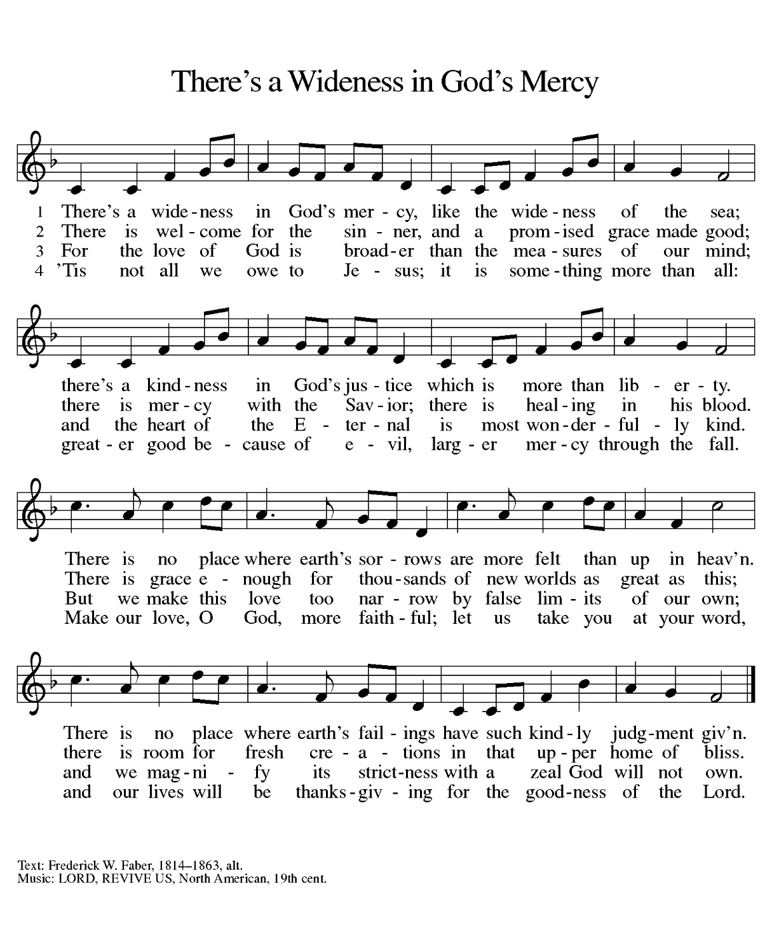

Offering Prayer
After the table is set, the assisting minister may lead one of the following or a similar prayer.
Let us pray.
God of power, God of plenty, all things belong to you. We bring your gifts to the table, that all might be fed. Form us into the body of your Beloved, Jesus Christ, our Savior.
Amen.
Great Thanksgiving
Dialogue
The Lord be with you.
And also with you.
Lift up your hearts.
We lift them to the Lord.
Let us give thanks to the Lord our God.
It is right to give our thanks and praise.
Preface
The thanksgiving continues with the preface for the day or season:
It is indeed right, our duty and our joy,
that we should at all times and in all places
give thanks and praise to you, almighty and merciful God,
through our Savior Jesus Christ;
who on this day overcame death and the grave,
and by his glorious resurrection opened to us the way of everlasting life.
And so, with all the choirs of angels,
with the church on earth and the hosts of heaven,
we praise your name and join their unending hymn:
Holy, Holy, Holy
Thanksgiving at the Table
The presiding minister continues, using one of the following or another appropriate form.
Holy, mighty, and merciful Lord,
heaven and earth are full of your glory.
In great love you sent to us Jesus, your Son,
who reached out to heal the sick and suffering,
who preached good news to the poor,
and who, on the cross, opened his arms to all.
In the night in which he was betrayed,
our Lord Jesus took bread, and gave thanks;
broke it, and gave it to his disciples, saying:
Take and eat; this is my body, given for you.
Do this for the remembrance of me.
Again, after supper, he took the cup, gave thanks,
and gave it for all to drink, saying:
This cup is the new covenant in my blood,
shed for you and for all people for the forgiveness of sin.
Do this for the remembrance of me.
Remembering, therefore, his death, resurrection, and ascension,
we await his coming in glory.
Pour out upon us the Spirit of your love, O Lord,
and unite the wills of all who share this heavenly food,
the body and blood of Jesus Christ, our Lord;
to whom, with you and the Holy Spirit,
be all honor and glory, now and forever.
Amen.
Lord’s Prayer
The presiding minister may introduce the Lord’s Prayer.
Gathered into one by the Holy Spirit, let us pray as Jesus taught us.
Our Father, who art in heaven,
hallowed be thy name,
thy kingdom come,
thy will be done,
on earth as it is in heaven.
Give us this day our daily bread;
and forgive us our trespasses,
as we forgive those
who trespass against us;
and lead us not into temptation,
but deliver us from evil.
For thine is the kingdom,
and the power, and the glory,
forever and ever. Amen.

Invitation to Communion
The presiding minister may address the assembly in these or similar words.
Jesus invites you to this table. Come, eat and live.
The assembly may be seated. The bread may be broken for the communion.
Communion
All people who trust that Christ is present in the Eucharist are welcome to receive communion. Those who do not partake in communion are welcome to come forward for a blessing from the pastor. Gluten-free hosts are available; please tell the pastor if you require one. Grape Juice may be selected in place of wine from the center circle of glasses in the distribution trays. We will commune one side of the congregation at a time, starting with the pulpit side. Please come forward, receive the host, then proceed to the communion assistant to retrieve a pre-filled glass of wine. Trays for the empty glasses are on the other side of the pulpit and piano respectively, on your way back to your seat.
When giving the bread and cup, the communion ministers say
The body of Christ, given for you.
The blood of Christ, shed for you.
and each person may respond
Amen.
The ministers commune either after or before others commune.
The assembly stands.
Post Communion Blessing
May the body and blood of our Lord Jesus Christ strengthen you and keep you in his grace.
Amen
Prayer after Communion
The assisting minister leads one of the following or a similar prayer after communion.
Let us pray.
Blessed be your name, O God, for we have feasted on your Word, Christ Jesus, the joy and delight of our hearts. Strengthened by this food, send us to gather the world to your banquet, where none are left out and all are satisfied. In Jesus’ name we pray.
Amen.
Sending
God blesses us and sends us in mission to the world.
Blessing
The presiding minister proclaims God’s blessing.
The God of glory,
☩ Jesus Christ, name above all names,
and the Spirit who lives in you,
bless you now and forever.
Amen.

Sending Song O Zion, Haste (ELW 668)

Dismissal
The assisting minister may send the assembly into mission.
Go in peace. God is at work in you.
Thanks be to God.
Peace
The Peace of Christ be with you Always.
And also with you.
The people may greet one another with a sign of Christ’s peace and share in a time of fellowship. Please be respectful of others’ sensibilities of comfortable interaction.

Postlude
Fanfare of Praise—Krug
From sundaysandseasons.com.
Copyright © 2023 Augsburg Fortress. All rights reserved. Reprinted by permission under Augsburg Fortress Liturgies Annual License #SB145099.
Onelicense #731001-A
CCLI # 207004521
New Revised Standard Version Bible, Copyright © 1989, Division of Christian Education of the National Council of the Churches of Christ in the United States of America. Used by permission. All rights reserved.
Revised Common Lectionary, Copyright © 1992 Consultation on Common Texts, admin Augsburg Fortress. Used by permission.
Serving Today September 24, 2023
Preaching and Presiding Rev. Brian Bennett
Communion Assistant Roland Kania
Live Stream Tom Hough
Greeters Edna Zimmermman/ Char Ingold
Reader John Mertens
Altar Guild Kathy Suhadolnik
Counters Dean Ingold/Jack Dellert

Serving next week October 1, 2023
Pastor Pastor J.J. Lynn
Communion Assistant Kathy Suhadolnik
Live Stream Ben Scariot
Greeters John Mertens/Karen Krenn
Reader Irene Fugh
Altar Guild Kathy Suhadolnik
Counters Tom Hough/Sue Spelic

