Emmanuel Lutheran Church of Etna
Fourth Sunday of Easter

Sunday, April 21, 2024
Pastor J.J. Lynn
Judith Erlen, Organist

Introduction
The image of the good shepherd shows us how the risen Christ brings us to life. It is the relationship between the shepherd and the sheep, one of mutual knowledge and love, that gives the shepherd authority. The shepherd’s willingness to lay down his life for the sheep shows his love. First John illustrates what it means to lay down our lives for one another by the example of sharing our wealth with any sibling in need.
First Reading: Acts 4:5-12
Peter and John had been arrested the previous day because they were proclaiming the news of the resurrection to the people. In today’s reading, Peter is filled with the Holy Spirit so that he can proclaim salvation in Jesus’ name to the religious authorities.
Second Reading: 1 John 3:16-24
Jesus’ death on our behalf is the clearest demonstration of divine love. This is the very love we share with others, not just through our words but especially through our deeds. In sharing such love we fulfill God’s commandments.
Gospel: John 10:11-18
In language that recalls the twenty-third psalm, Jesus describes himself as the shepherd who cares for his sheep. He is willing to die for them, and he is able to overcome death for them.

Gathering
The Holy Spirit calls us together as the people of God.
Welcome and Announcements
Brief announcements may be made, especially those related to the assembly’s participation in God’s mission in the world. Affirmation of Christian Vocation may be used here.
Prelude
One Shepherd, One Fold—Southbridge
Confession and Forgiveness
The assembly stands. All may make the sign of the cross, the sign that is marked at baptism, as the presiding minister begins.
Blessed be the holy Trinity, ☩ one God,
who forgives all our sin,
whose mercy endures forever.
Amen.
The presiding minister may lead one of the following or another prayer of preparation.
Almighty God, to whom all hearts are open, all desires known, and from whom no secrets are hid: cleanse the thoughts of our hearts by the inspiration of your Holy Spirit, that we may perfectly love you and worthily magnify your holy name, through Jesus Christ our Lord.
Amen.
One of the following or another confession is prayed.
Let us confess our sin in the presence of God and of one another.
Silence is kept for reflection.
Most merciful God,
we confess that we are captive to sin and cannot free ourselves. We have sinned against you in thought, word, and deed, by what we have done and by what we have left undone. We have not loved you with our whole heart; we have not loved our neighbors as ourselves. For the sake of your Son, Jesus Christ, have mercy on us. Forgive us, renew us, and lead us, so that we may delight in your will and walk in your ways, to the glory of your holy name.
Amen.
The presiding minister announces God’s forgiveness with these or similar words.
God, who is rich in mercy, loved us even when we were dead in sin, and made us alive together with Christ. By grace you have been saved. In the name of ☩ Jesus Christ, your sins are forgiven. Almighty God strengthen you with power through the Holy Spirit, that Christ may live in your hearts through faith.
Amen.
The service continues with gathering song.

Gathering Song The King of Love My Shepherd Is (ELW 502)
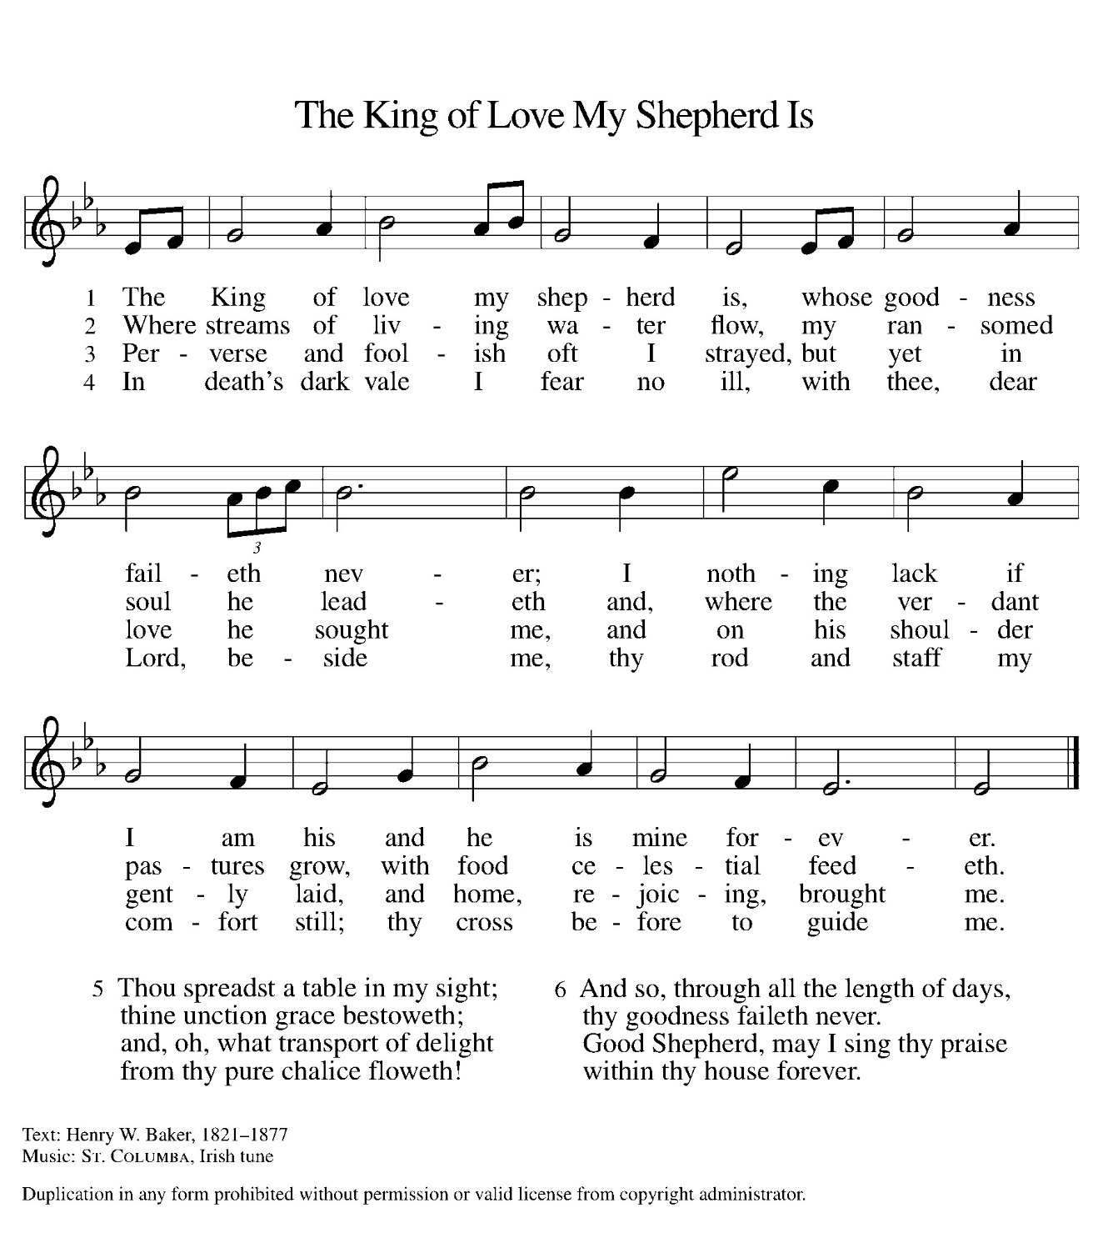
The time of gathering song may be brief or extended, and may include one or more of the following: hymns, psalms; a Kyrie; a canticle of praise.

Greeting
During this time, the presiding minister and the assembly greet each other.
The grace of our Lord Jesus Christ, the love of God,
and the communion of the Holy Spirit be with you all.
And also with you.
Kyrie
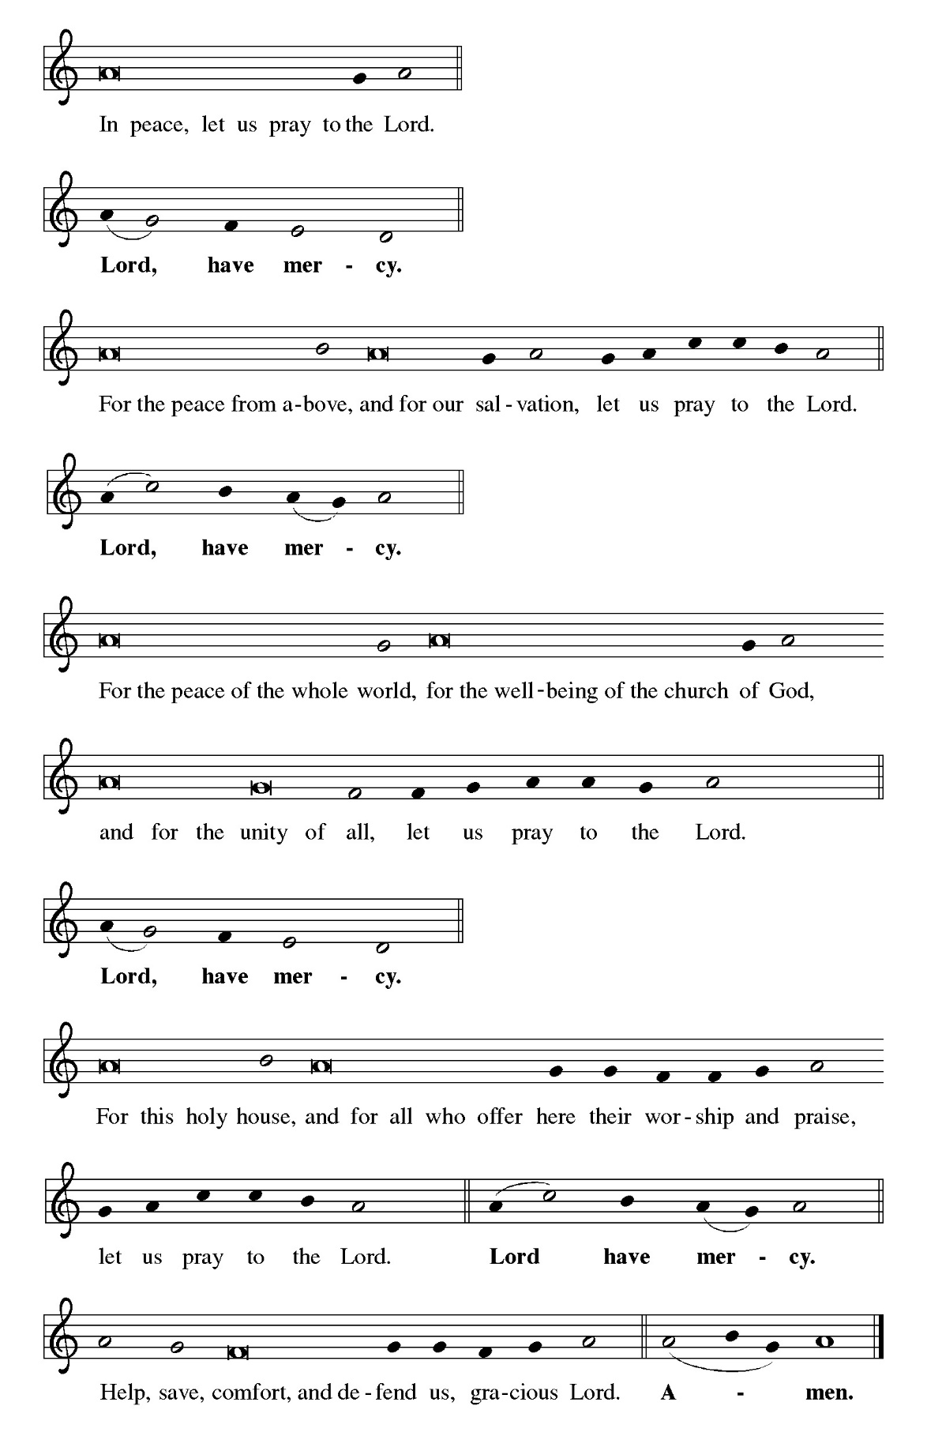
A Kyrie may be sung in dialogue between an assisting minister and the assembly.

Canticle of Praise
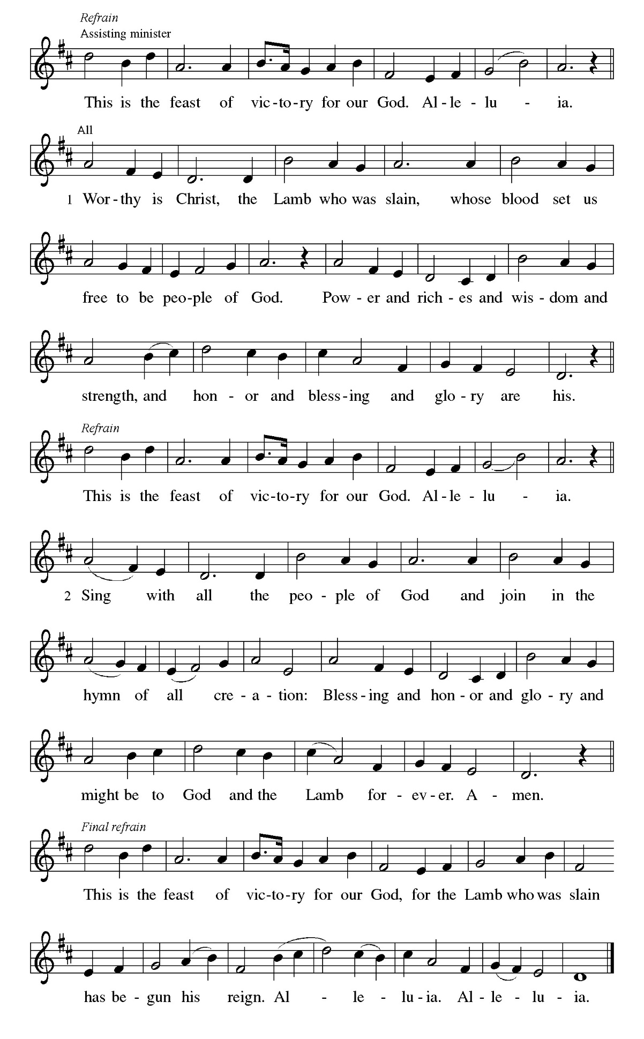
One of the following or another canticle of praise may be sung by all.

Prayer of the Day
The presiding minister leads the prayer of the day.
Let us pray.
A brief silence is kept before the prayer.
O Lord Christ, good shepherd of the sheep, you seek the lost and guide us into your fold. Feed us, and we shall be satisfied; heal us, and we shall be whole. Make us one with you, for you live and reign with the Father and the Holy Spirit, one God, now and forever.
Amen.
The assembly is seated.
Word
God speaks to us in scripture reading, preaching, and song.
Children's Time
Children are invited to the Chancel area for a brief story and lesson.
First Reading: Acts 4:5-12
The reading may be announced:
A reading from Acts.
⁵The next day [the] rulers, elders, and scribes assembled in Jerusalem, ⁶with Annas the high priest, Caiaphas, John, and Alexander, and all who were of the high-priestly family. ⁷When they had made the prisoners stand in their midst, they inquired, “By what power or by what name did you do this?” ⁸Then Peter, filled with the Holy Spirit, said to them, “Rulers of the people and elders, ⁹if we are questioned today because of a good deed done to someone who was sick and are asked how this man has been healed, ¹⁰let it be known to all of you, and to all the people of Israel, that this man is standing before you in good health by the name of Jesus Christ of Nazareth, whom you crucified, whom God raised from the dead. ¹¹This Jesus is
‘the stone that was rejected by you, the builders;
it has become the cornerstone.’
¹²There is salvation in no one else, for there is no other name under heaven given among mortals by which we must be saved.”
The reading may be concluded:
The word of the Lord.
The assembly responds:
Thanks be to God.
Psalm: Psalm 23
The psalm for the day is read in unison.
¹The Lord is my shepherd;
I shall not be in want.
²The Lord makes me lie down in green pastures
and leads me beside still waters.
³You restore my soul, O Lord,
and guide me along right pathways for your name’s sake.
⁴Though I walk through the valley of the shadow of death, I shall fear no evil;
for you are with me; your rod and your staff, they comfort me.
⁵You prepare a table before me in the presence of my enemies;
you anoint my head with oil, and my cup is running over.
⁶Surely goodness and mercy shall follow me all the days of my life,
and I will dwell in the house of the Lord forever.
Anthem
The Lord is My Shepherd—Owens
Second Reading: 1 John 3:16-24
The reading may be announced:
A reading from 1 John.
¹⁶We know love by this, that [Jesus Christ] laid down his life for us—and we ought to lay down our lives for one another. ¹⁷How does God’s love abide in anyone who has the world’s goods and sees a brother or sister in need and yet refuses help?
¹⁸Little children, let us love, not in word or speech, but in truth and action. ¹⁹And by this we will know that we are from the truth and will reassure our hearts before him ²⁰whenever our hearts condemn us; for God is greater than our hearts, and he knows everything. ²¹Beloved, if our hearts do not condemn us, we have boldness before God; ²²and we receive from him whatever we ask, because we obey his commandments and do what pleases him.
²³And this is his commandment, that we should believe in the name of his Son Jesus Christ and love one another, just as he has commanded us. ²⁴All who obey his commandments abide in him, and he abides in them. And by this we know that he abides in us, by the Spirit that he has given us.
The reading may be concluded:
The word of the Lord.
The assembly responds:
Thanks be to God.
Gospel Acclamation
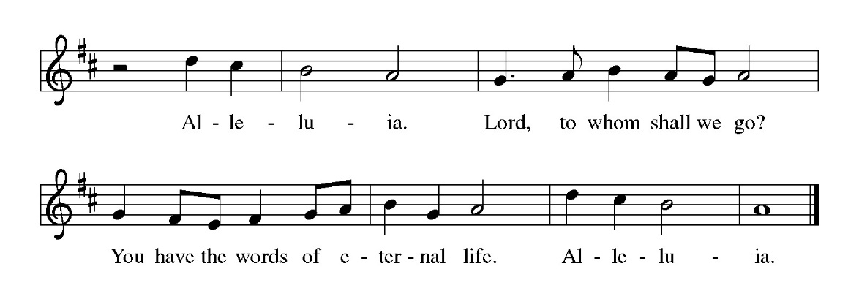
The assembly stands to welcome the gospel.

Gospel: John 10:11-18
The gospel is announced.
The holy gospel according to John.
Glory to you, O Lord.
[Jesus said:] ¹¹“I am the good shepherd. The good shepherd lays down his life for the sheep. ¹²The hired hand, who is not the shepherd and does not own the sheep, sees the wolf coming and leaves the sheep and runs away—and the wolf snatches them and scatters them. ¹³The hired hand runs away because a hired hand does not care for the sheep. ¹⁴I am the good shepherd. I know my own and my own know me, ¹⁵just as the Father knows me and I know the Father. And I lay down my life for the sheep. ¹⁶I have other sheep that do not belong to this fold. I must bring them also, and they will listen to my voice. So there will be one flock, one shepherd. ¹⁷For this reason the Father loves me, because I lay down my life in order to take it up again. ¹⁸No one takes it from me, but I lay it down of my own accord. I have power to lay it down, and I have power to take it up again. I have received this command from my Father.”
The gospel concludes:
The gospel of the Lord.
Praise to you, O Christ.
Sermon
The assembly is seated.

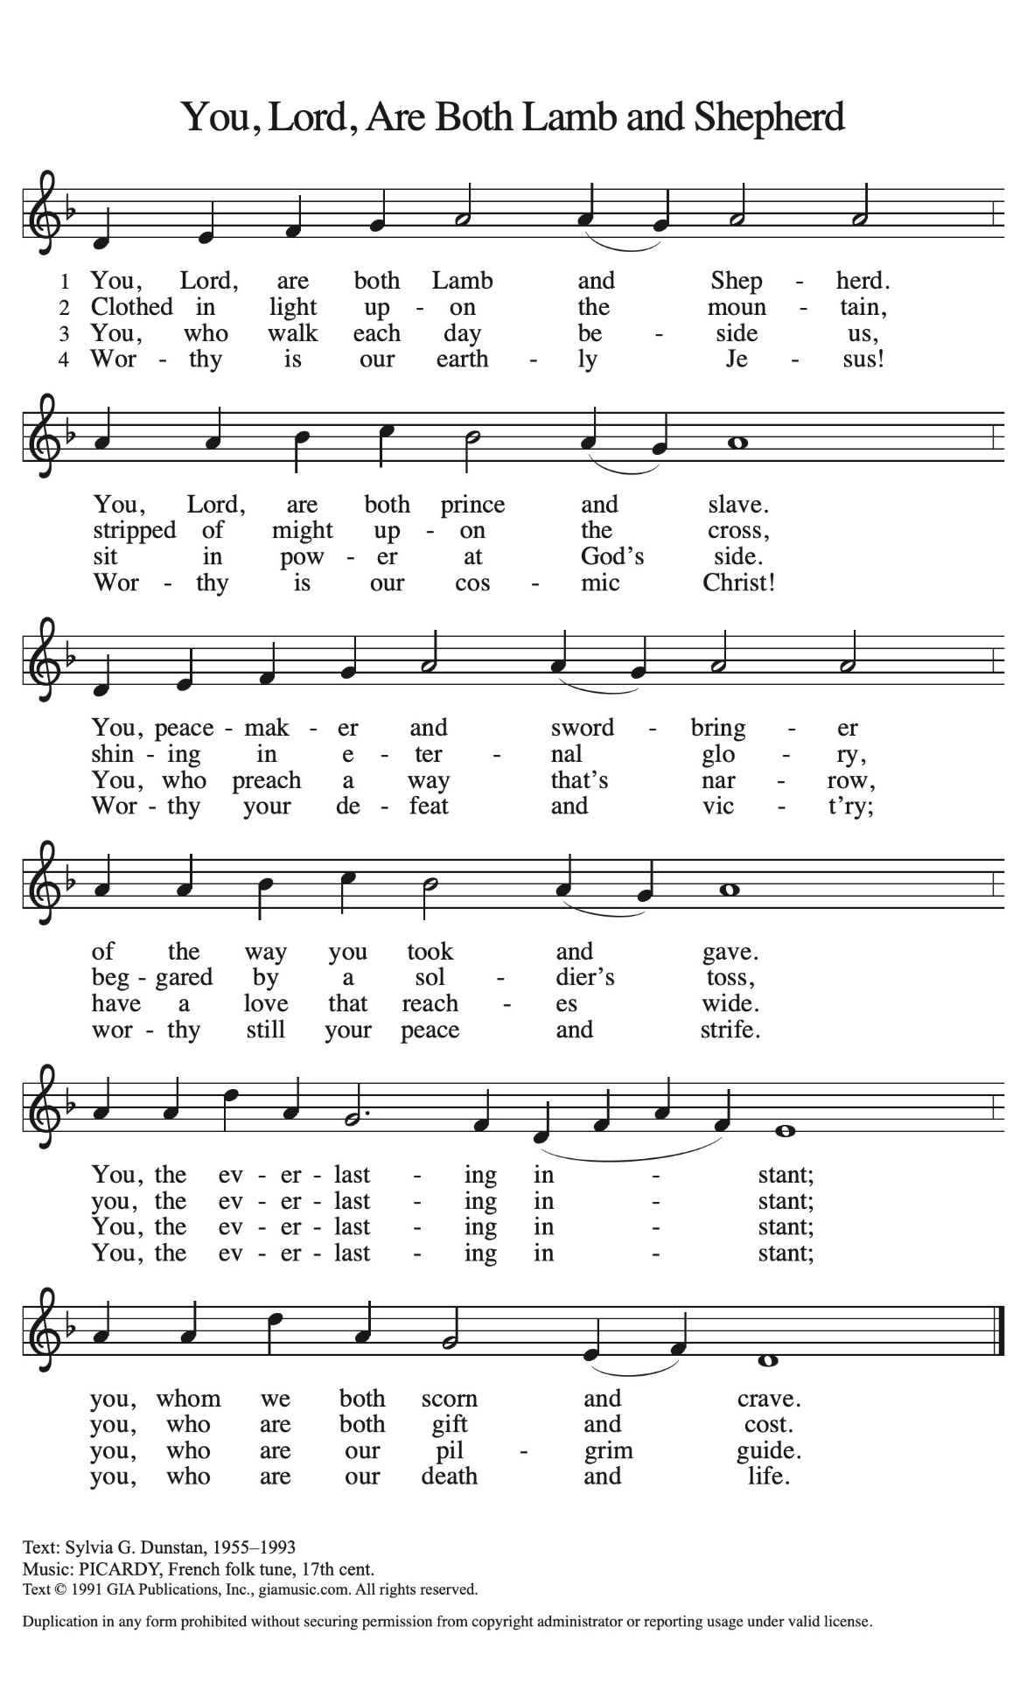
Hymn of the Day You, Lord, Are Both Lamb and Shepherd (ACS 954)
The assembly stands to proclaim the word of God in song.

Presentation
Candidates for baptism, sponsors, and parents gather with the ministers at the font. The assembly is seated.
The presiding minister may address the assembly in these or similar words:
God, who is rich in mercy and love, gives us a new birth into a living hope through the sacrament of baptism. By water and the Word God delivers us from sin and death and raises us to new life in Jesus Christ. We are united with all the baptized in the one body of Christ, anointed with the gift of the Holy Spirit, and joined in God's mission for the life of the world.
Sponsors for each candidate, in turn, present the candidates:
I present Aiden David Whetzel for baptism.
The presiding minister addresses parents or others who bring for baptism children who are not able to answer for themselves:
Called by the Holy Spirit, trusting in the grace and love of God, do you desire to have Aiden baptized into Christ?
Response: I do.
As you bring Aiden to receive the gift of baptism, you are entrusted with responsibilities:
to live with him among God's faithful people,
bring him to the word of God and the holy supper,
teach him the Lord's Prayer, the Creed, and the Ten Commandments,
place in his hands the holy scriptures,
and nurture him in faith and prayer,
so that Aiden may learn to trust God,
proclaim Christ through word and deed,
care for others and the world God made,
and work for justice and peace.
Do you promise to help Aiden grow in the Christian faith and life?
Response: I do.
The presiding minister addresses sponsors:
Sponsors, do you promise to nurture Aiden in the Christian faith as you are empowered by God's Spirit, and to help him live in the covenant of baptism and in communion with the church?
Response: I do.
The presiding minister addresses the assembly:
People of God, do you promise to pray for Aiden in his new life in Christ?
We do.
The assembly stands.

Profession of Faith
The presiding minister addresses candidates for baptism as well as the parents and sponsors of young children. The assembly may join in the responses.
I ask you to profess your faith in Christ Jesus, reject sin, and confess the faith of the church.
Do you renounce the devil and all the forces that defy God,
the powers of this world that rebel against God,
and the ways of sin that draw you from God?
Response:
I renounce them.
The presiding minister addresses the candidates and the assembly.
Do you believe in God the Father?
I believe in God, the Father almighty,
creator of heaven and earth.
Do you believe in Jesus Christ, the Son of God?
I believe in Jesus Christ, God’s only Son, our Lord,
who was conceived by the Holy Spirit,
born of the virgin Mary,
suffered under Pontius Pilate,
was crucified, died, and was buried;
he descended to the dead.*
On the third day he rose again;
he ascended into heaven,
he is seated at the right hand of the Father,
and he will come to judge the living and the dead.
Do you believe in God the Holy Spirit?
I believe in the Holy Spirit,
the holy catholic church,
the communion of saints,
the forgiveness of sins,
the resurrection of the body,
and the life everlasting.

*Or, “he descended into hell,” another translation of this text in widespread use.

Thanksgiving at the Font
Water may be poured into the font before or during the thanksgiving. At the font, the presiding minister begins the thanksgiving:
The Lord be with you.
And also with you.
Let us give thanks to the Lord our God.
It is right to give our thanks and praise.
Blessed are you, O God, maker and ruler of all things. Your voice thundered over the waters at creation. You water the mountains and send springs into the valleys to refresh and satisfy all living things.
Through the waters of the flood you carried those in the ark to safety. Through the sea you led your people Israel from slavery to freedom. In the wilderness you nourished them with water from the rock, and you brought them across the river Jordan to the promised land.
By the baptism of his death and resurrection, your Son Jesus has carried us to safety and freedom. The floods shall not overwhelm us, and the deep shall not swallow us up, for Christ has brought us over to the land of promise. He sends us to make disciples, baptizing in the name of the Father, and of the Son, and of the Holy Spirit.
Pour out your Holy Spirit; wash away sin in this cleansing water; clothe the baptized with Christ; and claim your daughters and sons, no longer slave and free, no longer male and female, but one with all the baptized in Christ Jesus, who lives and reigns with you in the unity of the Holy Spirit, one God, now and forever.
Amen.
The assembly may be seated.
Baptism
The presiding minister baptizes each candidate. The candidate is immersed into the water, or water is poured on the candidate's head, as the presiding minister says:
Aiden, I baptize you in the name of the Father,*
The candidate is immersed or water is poured on the candidate's head a second time:
and of the Son,
The candidate is immersed or water is poured on the candidate's head a third time:
and of the Holy Spirit.
Amen.
After each baptism, the assembly may respond with one of the following, a sung alleluia, or another acclamation (#209-213).
Blessed be God, the source of all life,
the word of salvation,
the spirit of mercy.
Clothed with Christ in baptism, the newly baptized may receive a baptismal garment.
The presiding minister continues:

Let us pray.
We give you thanks, O God, that through water and the Holy Spirit you give your daughters and sons new birth, cleanse them from sin, and raise them to eternal life.
Laying both hands on the head of each of the newly baptized, the minister prays for each:
Sustain Aiden with the gift of your Holy Spirit: the spirit of wisdom and understanding, the spirit of counsel and might, the spirit of knowledge and the fear of the Lord, the spirit of joy in your presence, both now and forever.
Amen.
The presiding minister marks the sign of the cross on the forehead of each of the baptized. Oil prepared for this purpose may be used. As the sign of the cross is made, the minister says:
Aiden, child of God, you have been sealed by the Holy Spirit and marked with the cross of Christ forever.
Amen.

*Or, " Name is baptized in the name of the Father, . . ."
Welcome
A lighted candle may be given to each of the newly baptized (to a sponsor of a young child) as a representative of the congregation says:
Let your light so shine before others
that they may see your good works
and glorify your Father in heaven.
The ministers and the baptismal group face the assembly. A representative of the congregation leads the assembly in the welcome.
Let us welcome the newly baptized.
We welcome you into the body of Christ and into the mission we share:
join us in giving thanks and praise to God
and bearing God's creative and redeeming word to all the world.
Those who have gathered at the font may return to their places. An acclamation (#209–215), psalm, or hymn may be sung.
The service continues with the prayers of intercession, or, if baptism has taken place in the gathering rite, with the greeting.

Prayers of Intercession
The prayers are prepared locally for each occasion. The following examples may be adapted or used as appropriate.
Rejoicing that Jesus is risen and love has triumphed over fear, let us pray for the church, the world, and all those in need of good news.
A brief silence.
Shepherding God, gather your church whenever we wander from you and one another. Empower our church in ministries around the world to worship and serve alongside global companions as equal partners and coworkers in the gospel. God of grace,
hear our prayer.
Lead us into prayer and recognition of fellowship with our synodical congregations. We pray today for the people of St. Luke’s, West View. Guide them as you guide us to share your hope and grace with their neighbors. God of grace,
hear our prayer.
Nurturing God, preserve the health of biomes and ecosystems. Inspire scientists, researchers, conservation organizations, and all people entrusted with the task of caring for creation, that we may be better stewards of the world around us. God of grace,
hear our prayer.
Almighty God, lead nations and communities to share resources, cooperate in solving conflicts, and listen to the wisdom of Indigenous peoples. Help all those with power to share it and to use such power for good. God of grace,
hear our prayer.
Loving God, protect the very young and the very old, those living without housing, victims of domestic abuse, and all who live with chronic illness or compromised immune systems. Guide communities to actively care for people who are vulnerable. God of grace,
hear our prayer.
Gracious God, help this and all communities of faith to listen for your voice. Call us away from things that distract us from following you. Invite us to more deeply love and serve people who are lonely, isolated, and on the margins. God of grace,
hear our prayer.
Here other intercessions may be offered.
Living God, we give thanks for our ancestors in faith (including Anselm of Canterbury and all who labored to help generations understand the good news of the gospel). Strengthen us to share the good news in our own day. God of grace,
hear our prayer.
Into your hands, most merciful God, we commend all for whom we pray, trusting in your abiding love; through Jesus Christ, our resurrected and living Lord.
Amen.

Meal
God feeds us with the presence of Jesus Christ.
Offering
During the singing of the Communion Hymn an offering is gathered for the mission of the church, including the care of those in need. During this time, the table is set. After the offering is gathered bread, wine, money, and other gifts may be brought forward. The assembly stands on the last verse.
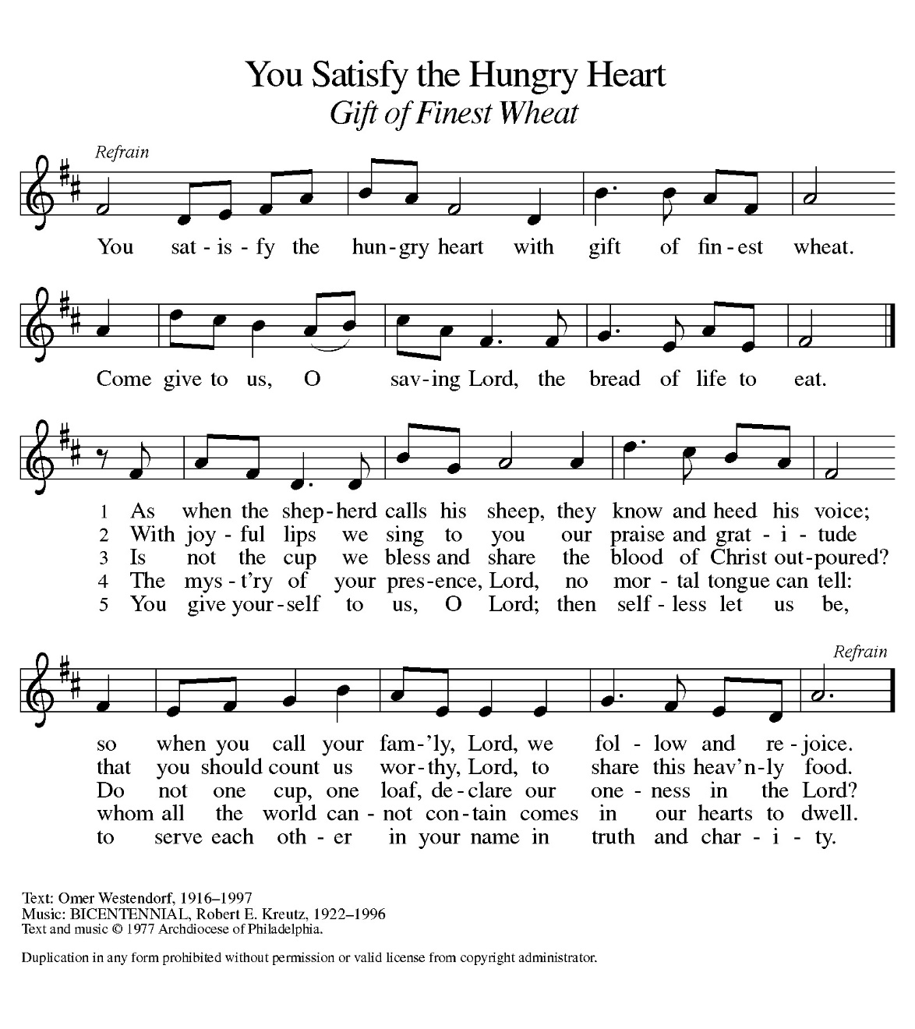
Communion Hymn You Satisfy the Hungry Heart: Gift of Finest Wheat (ELW 484)

Offering Prayer
After the table is set, the assisting minister may lead one of the following or a similar prayer.
Let us pray.
Blessed are you, O God, ruler of heaven and earth. Day by day you shower us with blessings. As you have raised us to new life in Christ, give us glad and generous hearts, ready to praise you and to respond to those in need, through Jesus Christ, our Savior and Lord.
Amen.
Great Thanksgiving
Dialogue
The presiding minister greets the assembly and invites all present to give thanks.
The Lord be with you.
And also with you.
Lift up your hearts.
We lift them to the Lord.
Let us give thanks to the Lord our God.
It is right to give our thanks and praise.
Preface
The thanksgiving continues with the preface for the day or season:
It is indeed right, our duty and our joy,
that we should at all times and in all places
give thanks and praise to you, almighty and merciful God,
for the glorious resurrection of our Savior Jesus Christ,
the true Paschal Lamb who gave himself to take away our sin;
who in dying has destroyed death,
and in rising has brought us to eternal life.
And so, with Mary Magdalene and Peter and all the witnesses of the resurrection,
with earth and sea and all their creatures,
and with angels and archangels, cherubim and seraphim,
we praise your name and join their unending hymn:
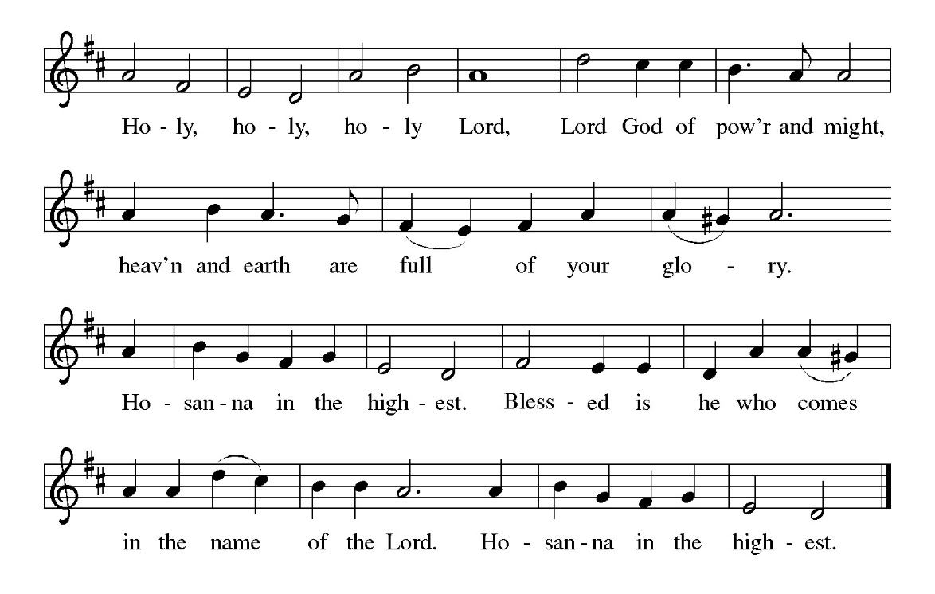
Holy, Holy, Holy

Thanksgiving at the Table
The presiding minister continues, using one of the following or another appropriate form.
Holy, mighty, and merciful Lord,
heaven and earth are full of your glory.
In great love you sent to us Jesus, your Son,
who reached out to heal the sick and suffering,
who preached good news to the poor,
and who, on the cross, opened his arms to all.
In the night in which he was betrayed,
our Lord Jesus took bread, and gave thanks;
broke it, and gave it to his disciples, saying:
Take and eat; this is my body, given for you.
Do this for the remembrance of me.
Again, after supper, he took the cup, gave thanks,
and gave it for all to drink, saying:
This cup is the new covenant in my blood,
shed for you and for all people for the forgiveness of sin.
Do this for the remembrance of me.
Remembering, therefore, his death, resurrection, and ascension,
we await his coming in glory.
Pour out upon us the Spirit of your love, O Lord,
and unite the wills of all who share this heavenly food,
the body and blood of Jesus Christ, our Lord;
to whom, with you and the Holy Spirit,
be all honor and glory, now and forever.
Amen.
Lord’s Prayer
The presiding minister may introduce the Lord’s Prayer.
Gathered into one by the Holy Spirit, let us pray as Jesus taught us.
Our Father, who art in heaven,
hallowed be thy name,
thy kingdom come,
thy will be done,
on earth as it is in heaven.
Give us this day our daily bread;
and forgive us our trespasses,
as we forgive those
who trespass against us;
and lead us not into temptation,
but deliver us from evil.
For thine is the kingdom,
and the power, and the glory,
forever and ever. Amen.
Invitation to Communion
These are the gifts of God for the People of God.
Taste and see that the Lord is good.

Communion
All people who trust that Christ is present in the Eucharist are welcome to receive communion. Those who do not partake in communion are welcome to come forward for a blessing from the pastor. Gluten-free hosts are available; please tell the pastor if you require one. Grape Juice may be selected in place of wine from the center circle of glasses in the distribution trays. We will commune one side of the congregation at a time, starting with the pulpit side. Please come forward, receive the host, then proceed to the communion assistant to retrieve a pre-filled glass of wine. Trays for the empty glasses are on the other side of the pulpit and piano respectively, on your way back to your seat.
When giving the bread and cup, the communion ministers say
The body of Christ, given for you.
The blood of Christ, shed for you.
and each person may respond
Amen.
The ministers commune either after or before others commune.
Post Communion Blessing
May the body and blood of our Lord Jesus Christ strengthen you and keep you in his grace.
Amen
Prayer after Communion
The assisting minister leads one of the following or a similar prayer after communion.
Let us pray.
Life-giving God, in the mystery of Christ’s resurrection you send light to conquer darkness, water to give new life, and the bread of life to nourish your people. Send us forth as witnesses to your Son’s resurrection, that we may show your glory to all the world, through Jesus Christ, our risen Lord.
Amen.
Sending
God blesses us and sends us in mission to the world.
Blessing
The presiding minister proclaims God’s blessing.
The Lord bless you and keep you.
The Lord’s face shine on you with grace and mercy.
The Lord look upon you with favor and ☩ give you peace.
Amen.

Sending Song Good Christian Friends, Rejoice and Sing! (ELW 385)
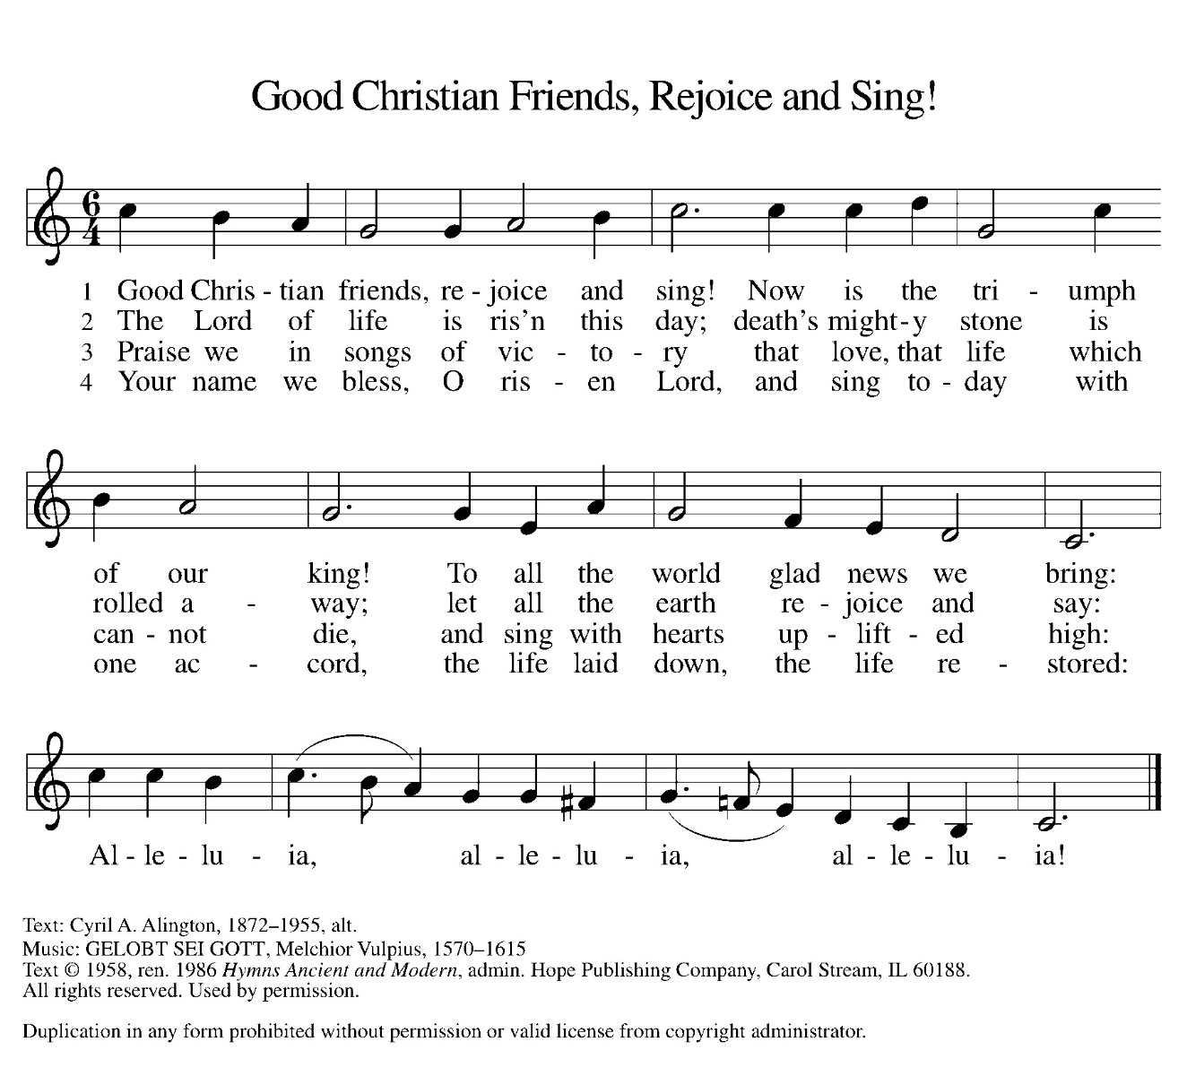
If “Now, Lord, you let your servant go in peace” was not sung at the end of the communion, it may be sung here, or another sending song may be sung.

Dismissal
The assisting minister may send the assembly into mission.
Go in peace. Serve the Lord.
Thanks be to God.
Peace
The Peace of Christ be with you Always.
And also with you.
The people may greet one another with a sign of Christ’s peace and share in a time of fellowship. Please be respectful of others’ sensibilities of comfortable interaction.
Postlude
Festive March—Lasky

Welcome into Christian fellowship
through the sacrament of baptism
Aiden David Whetzel
Son of Hailey and Nathan Whetzel,
born January 28, 2024,
Baptized in the name of the Father, Son, and Holy Spirit at worship this morning!

From sundaysandseasons.com.
Copyright © 2024 Augsburg Fortress. All rights reserved. Reprinted by permission under Augsburg Fortress Liturgies Annual License #SB145099.
Onelicense #731001-A
CCLI # 207004521
New Revised Standard Version Bible, Copyright © 1989, Division of Christian Education of the National Council of the Churches of Christ in the United States of America. Used by permission. All rights reserved.
Revised Common Lectionary, Copyright © 1992 Consultation on Common Texts, admin Augsburg Fortress. Used by permission.

